December 10, 2023 • 10:30am
Third Sunday of Advent

2

WELCOME
to Elk River Lutheran Church

Welcome to Elk River Lutheran Church! Whether you are joining us in-person or online, we’re glad you’re here. Elk River Lutheran Church is a forward-thinking congregation made up of people of all ages. We are a pretty new church (formed in 2009), located in a remodeled bank building on the Mississippi River in downtown Elk River. Our mission is: Trusting in God’s grace, an accepting, joyful community, serving God and neighbor.

We are a congregation of the Evangelical Lutheran Church in America (ELCA) and celebrate the work we’re able to do together as a denomination (to learn more about the ELCA visit www.elca.org). We welcome all people and as a Reconciling in Christ (RIC) congregation that welcome extends to the LGBTQ+ community.

Please fill out the enclosed Connection Form slip and drop it in an offering plate to receive more information about Elk River Lutheran or share prayer concerns.

Things to know for the service today:
- Bathrooms, complete with changing tables for little ones, are located in the Fellowship Hall in the corner opposite of the main entrance.
- We welcome kids with their wiggles and noises in worship. We are also aware that as a parent, time away from wiggles and noises can be a blessing too. You will find our staffed nursery (For children 5 and under) by the entrance in the far corner of the fellowship hall.
We hope and pray you have a wonderful worship experience here today. To learn more about the many opportunities to participate and volunteer with the ministries of ERLC, visit our website: https://www.elkriverlutheran.org

Worship Volunteers
 | Sunday, December 10 | Next Sunday, December 17
Greeters | Cathy Dalnes and Anthony Schaefer | Shari Howland and Nathan Sandvig
Ushers | Mark and Amelia Schwarze | Joe Livingston and Jeff Schrock
Scripture Reader |  | Sarah Chur
Communion Servers | Tom and LuAnn Wingard | Cathy Dalnes
Sunday Morning Communion  Setup/ CleanUp | Martha Hippe | Christine Hansen
Communion Steward | Debby Pouliot | Zoey Day
Mid-Week Communion Fill | Jodi Rosati | Paula Rose
PowerPoint Operator | Audrey Horner and Kevin Jenkins | Kevin Jenkins
Soundboard Operator | Jeff Schrock | Emily Rotz
Switcher Operator | Nick Campbell | Nick Campbell
If you would like to serve, Great! Please contact Taylor Quinn so we can get you filled in. If you cannot volunteer for the upcoming Sunday, please contact Taylor @ taylor@elkriverlutheran.org

Order of Worship
The Gathering of God’s People
Welcome
Lighting the Third Advent Candle
Sharing of the Peace
Gathering Song | “Angels We Have Heard on High (Deo)”
The Word of God Proclaimed
Prayer of the Day
Kids Christmas Program |  |  |  |  |  | A Room with a View
Song of the Day | (#267) “Joy to the World”
Sharing & Receiving the Gifts of God
Offering
Offertory Prayer
Confession and Forgiveness
Holy Communion
Words of Institution
The Lord’s Prayer
Communion Song |  |  | “In the Bleak Midwinter (Gloria)”
Communion Blessing
The Sending of God’s People
Community Announcements
Sending Blessing
Sending Song | “Hark the Herald Angels Sing/King of Heaven”
Sending Dialog
Liturgy, songs and lyrics are reprinted with permission. Current copyright licenses held with CCLI, OneLicense, and Augsburg Fortress. Duplication in any form prohibited without permission or valid license from copyright administrator.

LIGHTING OF THE Third ADVENT CANDLE

For the Children’s Christmas Program

This story has been told so many ways,
by Matthew and Luke, by children and choirs,
with flubs and forgotten lines that amplify
what is gorgeous and uncontainable
about God getting so close to our mortality,
to our trying and failing and trying some more.

There is room in the story for big yawns,
for the patina of musty costume accessories
and little ones singing so softly you can only
hear the choir director and a pin drop.

Watch Mary sneer at Joseph and wonder
about everything we cannot know for sure.
Give thanks for their bodies learning
to hold the story, to know that love is here.
Ordinary Blessings for the Christmas Season, by Meta Herrick Carlson, pg 19

So grateful for these students and their families who helped make today happen:
- John Beiswinger
- Cody Ethen
- Joel Ethen
- Herbert Lemire
- Helen Lemire
- Stanley Mugaas
- Emmett Pruchnik
- Brooke Raveling
- Jade Raveling

- Libby Ethen - Sheba, the sheep
- Levi Ethen - Buford the cow
- Cale Wornson-Stanley - Beau the cow
- Elliot Pruchnik - Barney the cow
- Payton Brown - Mac the horse
- Brynlee Overbye - Mable the horse
- Mattew Katzner - Manny the horse
- Jackson Larson - Remmy the donkey
- Teddy Mugaas - Joseph
- Nevaeh Katzner – Mary
- Melissa Macari-Coon
- The Band

And a special thank you to our student directors for all their help behind the scenes! Thank you, Katherine Horner and Clara Johnson!
Prayer Requests

Praise the Lord (joys and answered prayers):
- 2023 Kids’ Christmas Program and all that participated
- #SundayFunday with our Festive Sweaters

In Sympathy
- Family and Friends of Roger Bentz
- Family and Friends of Mary Nord, Dare Funeral Luncheon at ERLC on Monday, December 4th
- Family and Friends of Ken Provencher
- Family and Friends of Diane Jacobson

For Support
- Jared Stevens, had a friend pass away
- Those with mental health concerns and those who care for them.

Share Your Prayer Concerns:
- Email linda@elkriverlutheran.org
- Fill out on your connection form
- Contact the church office at (763) 595-1216
- Fill out form on church website at elkriverlutheran.org
Generally, prayer requests will run for 3 weeks. If more time is needed, please call the church office
Health concerns
- Steve Bucholz
- Norma Madsen, Cancer Scan
- Darrell Madsen, throat cancer treatment
- Garnet Novotny - cancer treatments
- Pat Kyro health concerns and recovery from surgery
- Kim Miller - cancer treatments (daughter of Tom and Marilyn Miller)
- Patty Sonneman, hospitalized and mass on brain. Aunt of Jenny Stanley
- Sara Anderson, Lorie Schulstad-Werk’s sister
- Jared Stevens Mom’s knee
- Jack Burris
- Elsie Provencher, back muscle spasms
- Tom Werk’s brother Al Werk, recovering from cancer
- Dale Ziner, Achilles tendon repair
- Robin Skeie, cousin of Diana Schansberg, in bad car accident and in ICU
- Krista Schrock: recovery from hip surgery
- Donn Granros
- Carol Sindelir, Val Nelson’s sister
- Linda Retel, ongoing treatment for inoperable brain cancer (friend of Pauline Kuhn)
- Diane Harding, ALS diagnosis
- Brian Harding
- Mary Wells, pancreatic cancer
- Nancy Naig
- Steve Lindberg, on hospice
- Diane McGrath, pancreatic cancer
- Ken Bucher
- Kris West, daughter of Bob and Sue Hagen
- Duane Jerde

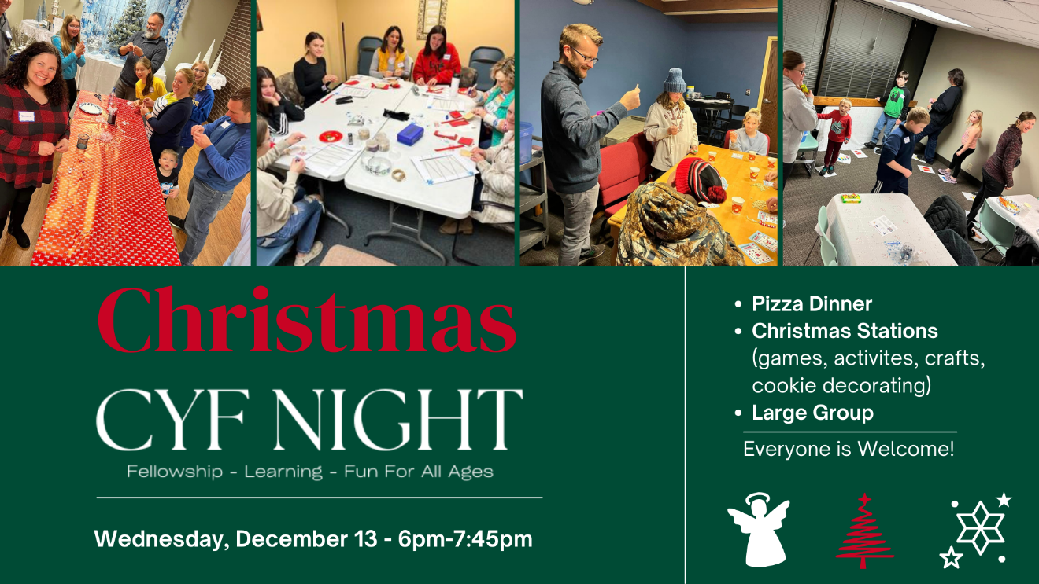
Volunteers still needed for December 13 and December 17

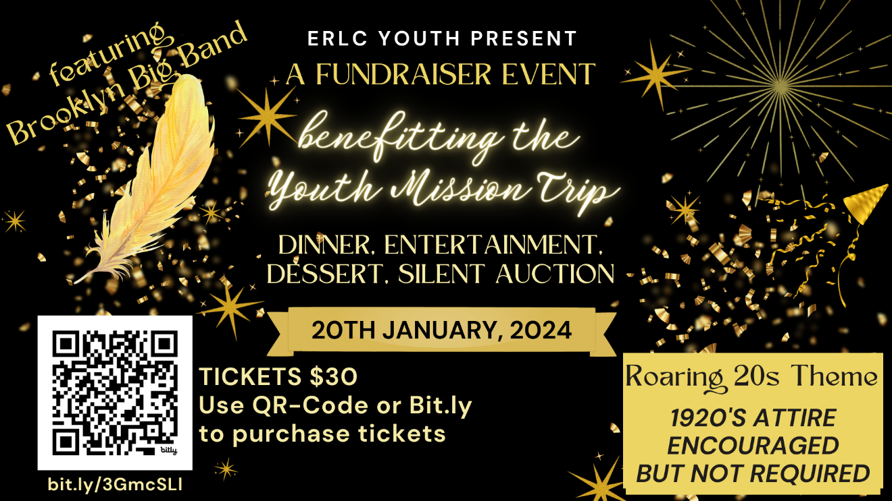

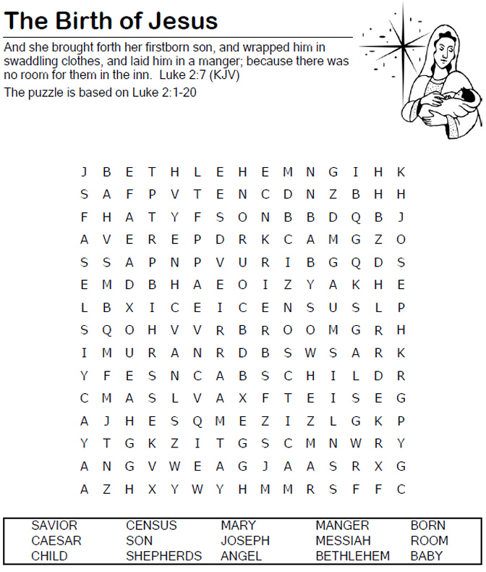

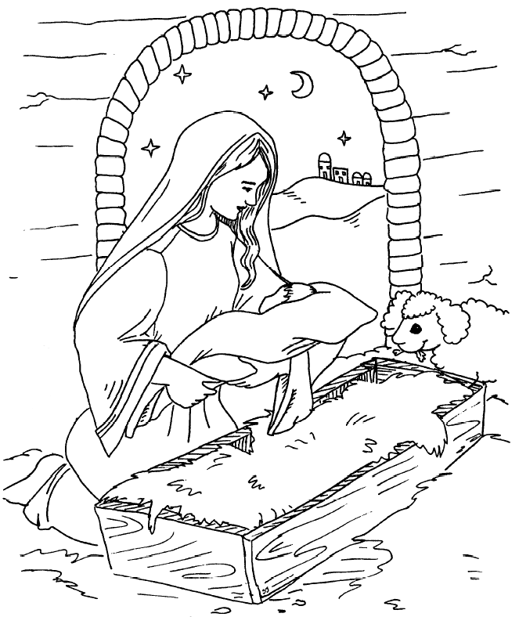
Today in the town of David a Savior has been born to you; he is Christ the Lord.
Luke 2:11

Week Ahead

SUNDAY
Kids Christmas Program
Festive Sweater Sunday
8:30am Traditional Worship
9:30am Fellowship Hour
10:30am Contemporary Worship
1:00pm Instrumental Ensemble Rehearsal

MONDAY
10:30am Caroling at Guardian Angels by the Lake
6:00pm Worship Band Rehearsal

TUESDAY
9:00am Quilting (Lower Level Quilting Room)
10:00am Text Study – Optional Fellowship Time starting at 9:30am (Lower Level Community Room)
6:00pm Riverside Ringers Rehearsal
7:00pm AA Meeting (Community Room)

WEDNESDAY
6:00pm CYF Night
7:00pm Blue Christmas Service of Solace and Comfort (Holy Trinity Episcopal Church)

THURSDAY
6:00pm Choir
FRIDAY
9:00am Women’s Coffee (Panera, Elk River)
9:00am Men’s Breakfast (Coborns, Elk River)

SATURDAY
8:00am Men’s Bible Study (Zoom Bible Study)

NEXT SUNDAY
Heritage Sunday
8:30am Traditional Worship with Kids Connect
9:30am Fellowship Hour
10:30am Contemporary Worship with Kids Connect
1:00pm Instrumental Ensemble Rehearsal

Small Groups
ERLC Quilting Group
Tuesdays @ 9AM
Lower Level at Church

Mission Quilts are made for Lutheran World Relief.
All skill levels welcome.
Text Study
Tuesdays @ 10AM
(Optional Fellowship @9:30AM)
Meeting in the Lower Level Community Room

Studying the bible text for the upcoming Sunday Worship along with the preaching pastor.
All are welcome . Come once or come every week
Men’s Breakfast
Fridays @ 9AM
Coborns, Elk River
Food – Fellowship
Women’s Coffee
Fridays @ 9AM
Panera, Elk River
Coffee – Food – Fellowship
Men’s Bible Study
Saturdays @ 8AM
On Zoom

Find a link at https://www.elkriverlutheran.org/adult-ministries.html
Genealogy Group
1st Thursday of the Month
10AM – 12 Noon
2nd Floor Conference Room

All are welcome even if you haven’t joined before. Meeting begins by sharing what each are working on, discoveries, questions, roadblocks and family stories.
Women’s Monthly Bible Study
3rd Monday of the Month
6:30PM
Lower Level at the Church

This group follows the Bible Studies of the Women’s ELCA magazine Gather.

Staff
Pastor Nathan Mugaas
763-242-8347
pastornathan@elkriverlutheran.org

Pastor Anne Schaefer
952-250-6974
pastoranne@elkriverlutheran.org

Linda Nielsen
Office Manager
763-595-1216
linda@elkriverlutheran.org
Confirmation Worship Notes Form
Taylor Quinn
Director of Music Ministry & Worship
816-519-2719
taylor@elkriverlutheran.org

Nick Campbell
Online Broadcast Specialist
ncdpv1@gmail.com

Lisa Griffin
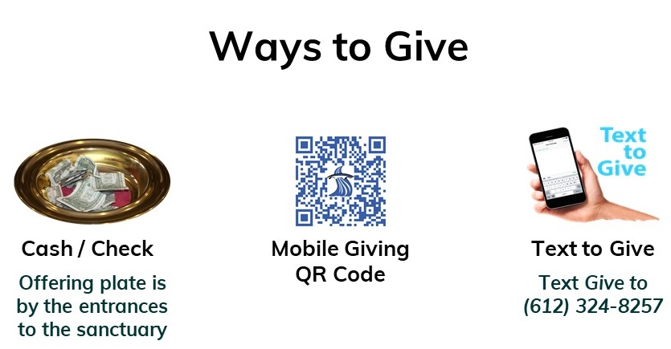
Staff Pianist
Additional Ways to Give:
- Automated Recurring Giving: Set up online via website give button, via the Tithe.ly phone app or by contacting the church office
- Stocks: consider donating stocks through a conversation with your financial advisor and the church.
612-709-8882
madeleinesmom@gmail.com

Brian Harding
Custodian

Lori Sundman
Bookkeeper
763-595-1216
ERLCBookkeeper@gmail.com

Nursery Attendants:
Clara Anderson, Emma Anderson
and Amy Brown
Congregational Council
President: David Katzner
Vice President: Kent Larson
Secretary: Matt Glasoe
Treasurer: Mark Johnson

Sue Hales
Julie Marie Haugen
Conni Natwick
Jeff Schrock
Jennifer Stanley
Tom Werk

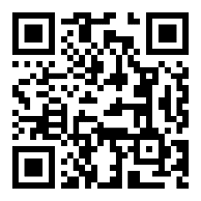
Confirmation Volunteer Form

Elk River Lutheran Church
729 Main Street – Elk River, MN 55330
(763) 595-1216
www.elkriverlutheran.org
Church Office Hours: Mon-Thurs 9 am – 4 pm; Fri Closed

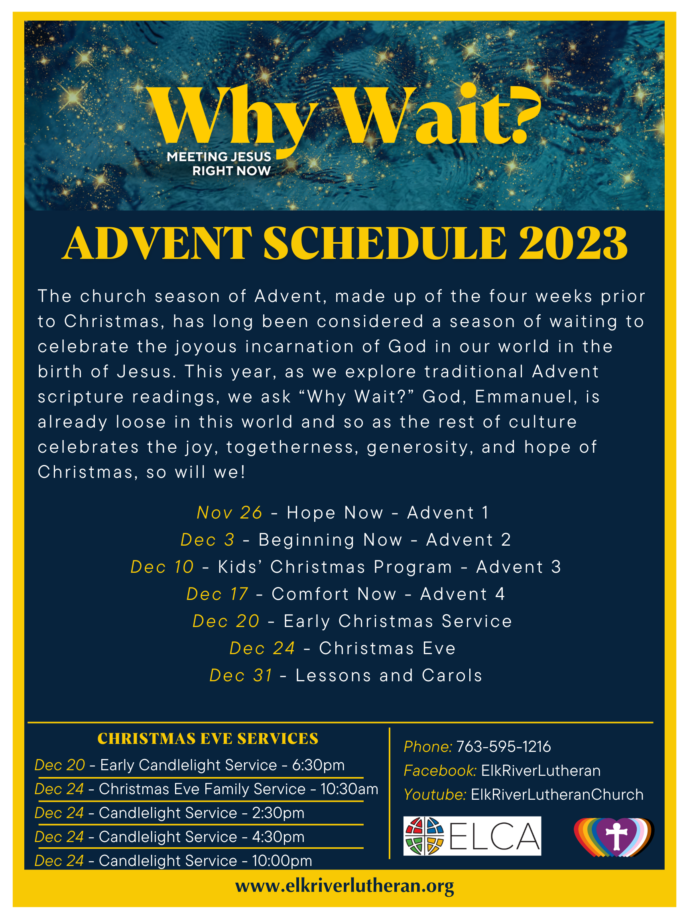
Nursery will be available for all services except the 10pm Candlelight Service

